SAVE THE DATE!
Rotary Club of Reading’s 32nd Charity Golf Day

Tuesday 15th September 2020

Shotgun Start at 9.00am

Due to imminent closure your last chance to play
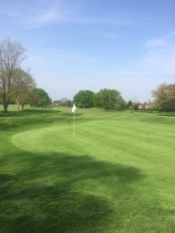
Reading Golf Club - one of the finest local courses

18 hole Stableford Competition for Teams of Four

Bacon Buttie & Coffee Welcome

On Course Refreshments

Competition Prizes

Nearest the Pin in Two

Nearest the Pin and Prize Holes

Lunch

Tombola

All-inclusive price of £270 for a team of four
This popular event has raised tens of thousands of pounds for Rotary charities & good causes both local & international. Your support will ensure another successful and enjoyable day.

For further information and a booking form contact:

simon@creffields.co.uk or go to: www.readingrotary.co.uk

